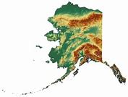

# Alaska Assembly

## Mission Statement

## 

Our Alaska Assembly is dedicated to the restoration of a complete and fully operational land and soil jurisdiction State and County court system serving the people of Alaska, the preservation of the National Trust, the enforcement of the Public Law, the upholding of the Federal Constitution owed to our State and People, the re-population of our land and soil jurisdiction, the filling of vacated Public Offices, and the reclamation of our material and intellectual public and private assets. To these ends we, the living people of Alaska, have called the **eligible** Alaskan Nationals and Electors to assemble and to serve as Jurors and Officers, and we have established the process and procedure to qualify jurors and others competent to hold State Citizenship and Public Office. We do this peacefully and without rancor in the exercise of our unincorporated powers and capacities.